Alkenes

Alkenes are unsaturated hydrocarbons.
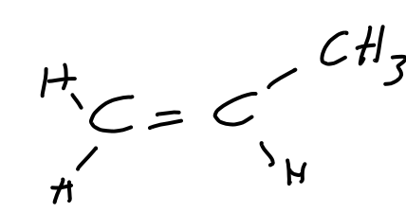
Alkenes shoulld be drawin in the form:

This is because it helps with isomerism.

Isomerism
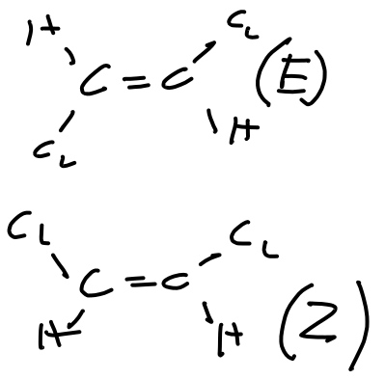
E/Z isomerism is due to rotation of groups around the central C=C bond.

Cis/Trans is a special E/Z where at least one side of the alkene must have the same type of group.

